Harrisonburg City School Board

**Resolution condemning racism and affirming Harrisonburg City Public School's commitment to an inclusive school environment for all**

WHEREAS, members of the Harrisonburg City School Board, as well as the Harrisonburg City Public Schools staff, are saddened and outraged by recent events that demonstrate the prejudice and injustice that persists in our country; we grieve and stand in solidarity with members of our Black community. We also recognize that words are just rhetoric until they are turned into action;

WHEREAS, our response and responsibility must be to evoke actual change within our school division and community by dismantling the social structures and systems of power that marginalize and oppress members of our community. Racism and hate have no place in our schools or our society, and we must protect the Constitutional rights of every person who lives, works and learns in our community.

WHEREAS, **we cannot be silent.** We urgently must act to stop the racial injustice that harms and anguishes our black community and all students of color, who are our family, friends, neighbors, students, staff members and fellow Americans. The first step is to look within ourselves, recognize the biases we hold, and do the difficult but essential work to learn and improve.

WHEREAS, **we must listen.** We can start by listening to and reading about the experiences of others, in particular those in our black community. Those who have endured discrimination and intolerance deserve to be heard as they share the stories and truth about their experiences and feelings, and we must seek with great empathy to understand their challenges and their pain;

WHEREAS, **we must learn.** It is time to engage our schools and community in meaningful and honest conversation about racial inequality and to work together to support our shared conviction that racism must end. As a school division, not only will we examine our curriculum to ensure that it portrays an accurate account of black oppression and the oppression of other marginalized groups, but even more so the significant accomplishments and contributions of African Americans that have *positively* impacted our nation and the world; we will ensure that positive and relevant reflections of the black community and all people of color are present in the literature we read and in the learning we embark on together.

WHEREAS, **we must lead.** Each of us, individually and collectively, is responsible for creating and nurturing an anti-racist learning environment where every child is respected and valued for who they are, regardless of their skin color. We must actively acknowledge, address and prevent racial bias that occurs as a result of division policies, practices and actions. We will continue to build diversity within our staff so that our students see themselves in the faces of their teachers and

WHEREAS, **we must do better.** We acknowledge that we have much to learn, that there are gaps in our systems, and that sincere attempts at equity often fall short. We will seek the perspective of our black students, and all students of color and our families who have been overlooked by our society, our community, and our school division. Our school division can be and will be a sanctuary of safety in our community and a beacon of light for other school divisions and communities, as we build and strengthen trust with those we serve, and model the acceptance of all people.

THEREFORE, BE IT RESOLVED that we, the members of the Harrisonburg City School Board, stand steadfast in our commitment to foster an inclusive educational environment where every student, teacher, support professional, parent and community member is treated with dignity and respect, as well as our commitment to continue fighting for racial justice and human and civil rights for all.

Approved by the Harrisonburg City School Board this 16th day of June 2020.

Signed: -Michael Richards -

Harrisonburg Superintendent

Andrew I Kohen

Signed: Andrew I Kohen

Harrisonburg City School Board Chair

Signed:

Kristen Lofflin

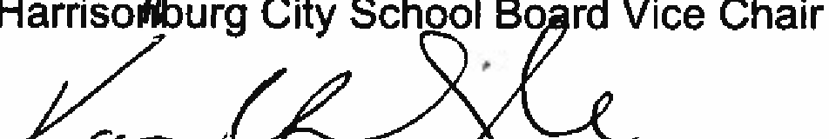--

-

-- ---· -· -

Signed: , . \-:::'.I -- *,D*-*.* --

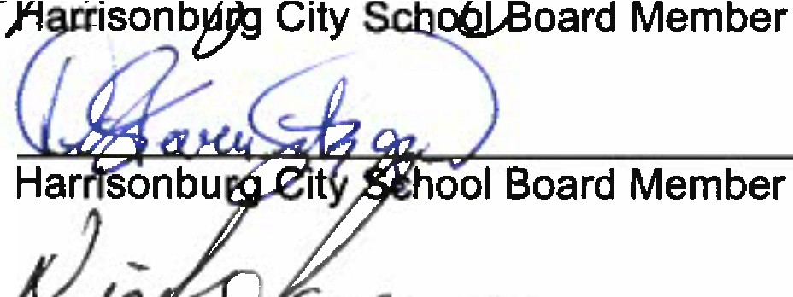

.**"1-:zsq:,f** H D41 "7 o'.

/" *:::'C:1'-- '>¥.*

<"'.?==

Signed:

Signed:

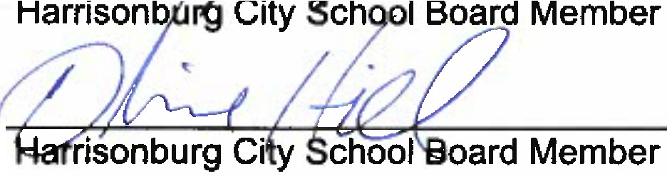

, ,, */,' y*

" *r* 6,'L:.:.,. r:

Signed: